Mandatory Experiment 4.2

Standardisation of a hydrochloric acid solution using a standard solution of sodium carbonate

Student Material

Theory

Laboratory grade hydrochloric acid is not sufficiently pure to be used as a primary standard. In this experiment, a standard solution of sodium carbonate is used to determine the exact concentration of a hydrochloric acid solution.

The neutralisation reaction that occurs is as follows:

Na₂CO₃ + 2HCl → 2NaCl + H₂O + CO₂
1 mole 2 moles 2 moles 1 mole 1 mole

Methyl orange indicator solution is used. At the end-point – when neutralisation just occurs – the indicator changes colour from yellow to peach/pink.

Chemicals and Apparatus

0.1 M sodium carbonate solution
Unknown solution of hydrochloric acid
Methyl orange indicator 

Burette (50 cm³)
Retort stand
Boss-head
Clamp
Filter funnel
Conical flask (250 cm³)
Pipette (25 cm³)
Pipette filler
Wash bottle
White card
White tile
Beakers (250 cm³)
Safety glasses

Procedure

NB: Wear your safety glasses.

- Pour approximately 50 cm³ of the hydrochloric acid solution into a clean dry beaker.

- Rinse the burette with deionised water, and clamp it vertically in the retort stand.

- Using the funnel, add a little of the hydrochloric acid solution to the burette; rinse the burette with this solution and discard it.

- Fill the burette with hydrochloric acid solution above the zero mark. Remove the funnel. Using the tap at the base of the burette, allow the acid to flow into a beaker until the level of liquid is at the zero mark. Ensure that there are no air bubbles in the nozzle of the burette.

- Hold a piece of white card behind the burette in order to see the level of liquid more clearly. Record the level of liquid in the burette in your notebook. Remember to record the lower level of the meniscus at eye level.

- Rinse the pipette with some deionised water and then with some of the sodium carbonate solution. Rinse the conical flask with deionised water only.

- Using the clean pipette and a pipette filler, transfer 25 cm³ of the sodium carbonate solution into the clean conical flask. Add 2-3 drops of methyl orange indicator. Note the colour of the solution. A white tile underneath the conical flask will make the colour more obvious.

- Carry out a rough titration by adding hydrochloric acid solution from the burette in approximately 1 cm³ lots to the conical flask, swirling the flask constantly, until the colour of the solution in the conical flask changes. During the titration, any solution adhering to the sides of the conical flask during the titration should be washed down with deionised water.

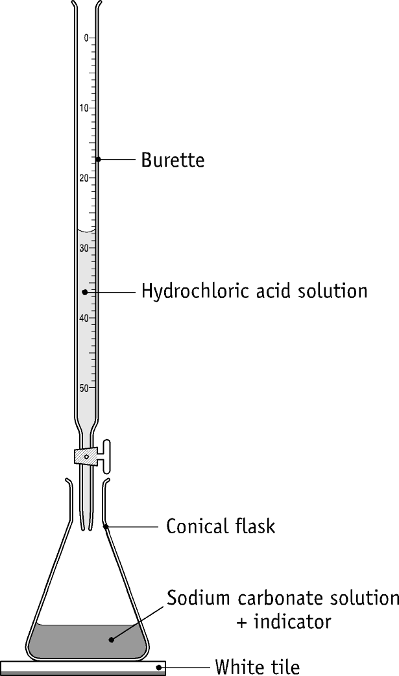

- Note the burette reading and calculate how much acid was used. This is only a trial titration and gives the approximate value of the end point.

- Wash out the conical flask with water. Pipette 25 cm³ of sodium carbonate solution into the flask and add 2-3 drops of methyl orange indicator.

- Repeat the titration for a more accurate reading, by adding in hydrochloric acid solution from the burette rapidly to within 2 cm³ of the end point. Swirl the conical flask vigorously, and, while continuing to swirl, add the hydrochloric acid solution dropwise from the burette. When a definite permanent colour change occurs, note the reading.

- Repeat the titration (steps 10 and 11) until two readings agree within 0.1cm³.

- Calculate the concentration of the hydrochloric acid solution.

Table of Results

Rough titre =
Second titre =
Third titre =
Average of accurate titres =

Volume of sodium carbonate solution used in each titration =
Concentration of sodium carbonate solution =
Concentration of hydrochloric acid solution =

Questions relating to the experiment

- Why is a conical flask, rather than a beaker, used in the experiment?

- Why is the funnel removed from the burette after adding the acid solution?

- In using a burette, why is it important (a) to rinse it with a little of the solution it is going to contain, (b) to clamp it vertically, (c) to have the part below the tap full?

- The following procedures were carried out during the titration:
(i) The sides of the conical flask were washed down with deionised water.
(ii) The conical flask was frequently swirled or shaken.
Give one reason for carrying out each of these procedures.

- Why is a rough titration carried out?

- Why is more than one accurate titration carried out?

- Explain why hydrochloric acid is not used as a primary standard.

- Can any of the following be used as primary standards: NaOH, H₂SO₄, HNO₃? Explain your answer.

- If you used only 10cm³ of sodium carbonate solution in the conical flask, calculate how much acid would be required to neutralise it.

- Describe, briefly, how a pure dry sample of sodium chloride could be obtained having carried out the titration.

Teacher Material

- Phenolphthalein is not suitable for use as an indicator in this titration, as it does not change colour in the appropriate pH range.

- Methyl red is not recommended for use as an indicator in this titration. It is not really suitable because the carbon dioxide formed in the reaction causes the indicator to change colour to pink before the actual endpoint.

Preparation of reagents

Hydrochloric acid solution: Using a fume cupboard, an approximately 0.2 M hydrochloric acid solution is made by adding with stirring 17 cm³ of concentrated hydrochloric acid to about 600 cm³ of deionised water and diluting to 1 litre with deionised water. Stopper, and mix thoroughly.

0.1 M sodium carbonate solution: Using a balance, measure accurately 10.6 g of pure anhydrous sodium carbonate on a clock glass. Transfer to a beaker containing about 200 cm³ of deionised water. To ensure that all the sodium carbonate is transferred, use a wash bottle to rinse the clock glass with deionised water, and add the rinsings to the beaker. Stir the mixture with a stirring rod until the sodium carbonate has fully dissolved. Using a wash bottle, wash off the solution on the stirring rod with deionised water into the beaker. Pour the solution through a clean funnel into a 1 litre volumetric flask. Using a wash bottle, rinse out the beaker several times with deionised water, and add the rinsings to the solution in the flask. Rinse the funnel with deionised water, allowing the water to run into the flask. Carefully make up the volume to 1 litre with deionised water. Stopper the flask and invert it several times to ensure a homogeneous solution

Quantities per working group

150 cm³ hydrochloric acid solution
150 cm³ sodium carbonate solution
5 cm³ methyl orange solution

Safety considerations

- Safety glasses must be worn.
- A fume cupboard should be used when making up the hydrochloric acid solution.

Chemical hazard notes

Sodium carbonate _{i}: Sodium carbonate is irritating to the eyes and skin, and its dust irritates the lungs. Wear eye protection.

Concentrated hydrochloric acid 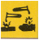 is very corrosive to eyes and skin, and its vapour
is very irritating to lungs.

Solutions of methyl orange usually contain 50% ethanol and are flammable.

Disposal of wastes

Dilute with water, and flush to foul water drain.

Specimen Results

Rough titre = 27.0 cm³
Second titre = 26.6 cm³
Third titre = 26.7 cm³
Average of accurate titres = 26.65 cm³
Volume of sodium carbonate solution used in each titration = 25.0 cm³
Concentration of sodium carbonate solution = 0.1 M

Specimen Calculations

(a) First principles method

Volume of Na₂CO₃ solution used = 25.0 cm³
Moles of Na₂CO₃ used = 25.0 x 0.1 / 1000 moles
= 0.0025 moles
Balanced equation:

2HCl + Na₂CO₃ → 2NaCl + H₂O + CO₂
2 mole 1 mole 2 moles 1 mole 1 mole

Moles of HCl reacting = 2 x 0.0025 moles
= 0.005 moles
Volume of HCl solution used = 26.65 cm³
Moles/ cm³ of HCl used = 0.005 / 26.65
= 0.00019
Moles/litre of HCl used = 0.19
Concentration of hydrochloric acid solution = 0.19 M

(b) Formula method

V_{A} x M_{A} x n_{B} = V_{B} x M_{B} x n_{A}

26.65 x M_{A} x 1 = 25.0 x 0.1 x 2

M_{A} = 25.0 x 0.1 x 2 / (26.65 x 1) M
= 0.19 M

Concentration of hydrochloric acid solution = 0.19 M

Solutions to student questions
- Why is a conical flask, rather than a beaker, used in the experiment?

To allow easy mixing of the contents, by swirling.

- Why is the funnel removed from the burette after adding the acid solution?

So that drops of solution from the funnel will not fall into the burette.

- In using a burette, why is it important (a) to rinse it with a little of the solution it is going to contain, (b) to clamp it vertically, (c) to have the part below the tap full?

  - To remove any residual water, and so avoid dilution of the acid solution when it is poured into the burette.
  - To enable the liquid level to be read correctly.
  - To ensure that the actual volume of liquid delivered into the conical flask is read accurately.

- The following procedures were carried out during the titration:
(a) The sides of the conical flask were washed down with deionised water.
  - The conical flask was frequently swirled or shaken.
Give one reason for carrying out each of these procedures.

  - To ensure that all of the acid added from the burette can react with the base.
  - To ensure complete mixing of the reactants.

- Why is a rough titration carried out?

To find the approximate end-point. This information enables the subsequent titrations to be carried out more quickly.

- Why is more than one accurate titration carried out?

To minimise error by getting accurate readings within 0.1 cm³ of each other.

- Explain why hydrochloric acid is not used as a primary standard.

The exact concentration of any hydrochloric acid solution is not known,
unless it is prepared from standard ampoules. Laboratory grade hydrochloric
acid is not sufficiently pure.

- Can any of the following be used as primary standards: NaOH, H₂SO₄, HNO₃? Explain your answer.

A primary standard should be available in a highly pure state and be stable. None of these substances are available pure because (i)
NaOH readily absorbs water and carbon dioxide from the air
(ii) concentrated H₂SO₄ readily absorbs water from the air
(iii) HNO₃ breaks down, releasing NO₂ gas.

- If you used only 10cm³ of sodium carbonate solution in the conical flask, calculate how much acid would be required to neutralise it.

10 cm³ Na₂CO₃ solution used, at concentration of 0.1 M
=> 1 x 10⁻³ moles Na₂CO₃
=> 2 x 10⁻³ moles HCl required
Concentration of HCl is 0.19 M
1000 x 2 x 10⁻³ / 0.19 cm³ required = 10.5 cm³

- Describe, briefly, how a pure dry sample of sodium chloride could be obtained having carried out the titration.

Using the information provided by the titration results, add just enough hydrochloric acid to exactly neutralise 25 cm³ of sodium carbonate. The indicator should not be added. Gently heat the solution until all the water has evaporated to dryness. A sample of sodium chloride will remain in the beaker.

